All Atlassian

* + Implementation
  + Architecture
  + Licensing
  + Training
  + Support

For the Enterprise

# Enterprise Architecture

We work with clients to develop a modern IT architecture that improves their business performance, driving revenue, flexibility and speed, while optimizing IT spend.

Digital companies take the interaction with their customers to a new level. They simplify customer experience while introducing more value adding services. At the same time, they use technology to constantly optimize their own processes. As a result, the role of IT has profoundly changed. Organizations increasingly become technology companies through fundamental shifts in their core IT capabilities.

One of the core challenges for established organizations is the integration of the inevitable patchwork of systems. This typically fails to deliver the material results and the added value that CEOs demand. The need to rapidly add new capabilities further increases the complexity of IT in large enterprises. This leads to overwhelming cost of maintenance and change, as well as response times slowed to unacceptable levels. As organizations strive to compete with digital natives, we can help them adopt a much different approach to designing and managing enterprise architecture.

Our approach emphasizes continual changes and modular design of business capabilities as well as the technologies & data behind them. It compels executives to take a comprehensive view of their estate across different shifts, allowing to manage them in a way that mitigates interdependencies and emphasizes speed with relentless focus on customer value. Our work with companies exploring digital transformations suggests that a shift to a modular perpetual-evolution model can result in optimized IT spend, faster product-development cycles and greater operational efficiencies—outcomes that are in sync with [customers’ expectations](https://www.mckinsey.com/business-functions/operations/our-insights/mastering-the-digital-advantage-in-transforming-customer-experience).

# Agile and DevOps Transformation

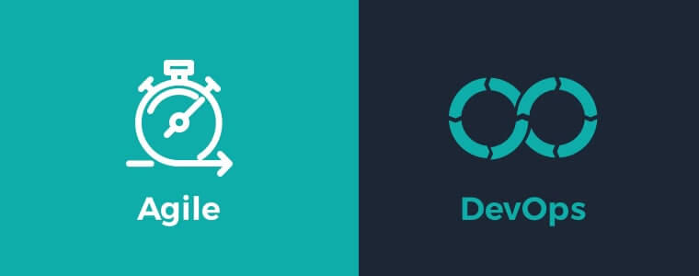

[Agile development](https://www.neotys.com/insights/agile-testing) is a methodology that is a time-bounded and iterative approach to building software that works incrementally from the start of the project, rather than delivering it all at once. It ties in with the [DevOps](https://www.neotys.com/insights/devops-testing) concept in that it is a way of structuring development to fit more comfortably with integrating development and operations.

There are many ways to implement [Agile](https://www.neotys.com/solutions/agile-continuous-performance-testing) methods, but they all share familiar concepts.

First, the customer and the developers agree on a list of features the software should deliver. The customer prioritizes the features, and developers estimate how long each item will take.

**Sprinting**

Once the feature list has been approved, development goes into time-bounded sprints that consist of building, testing, and deployment until all the items are done.

[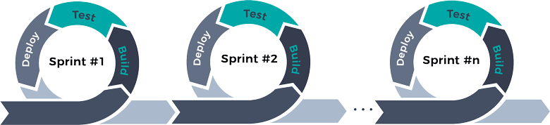](https://www.neotys.com/blog/wp-content/uploads/2018/05/Agile-Cycle-01.png)

Along the way, the goals of a sprint may be revised to reflect the progress that has been made by previous ones.

Analysis, design, coding, and testing are done continuously on agile projects. It doesn’t go in a linear progression as it does in monolith projects. It’s all happening at once.

Development is going to be iterative. It starts simple, then adds complexity. “Things are going to change” is an accepted axiom here. That leads to adaptive planning, where the scope of things that are done will also change. Customers, for example, may change how they describe what they want when they see what is coming out of the process.

**The Scrum**

Scrum is the name given to a framework focused on a sprint as well as the team that is involved in that sprint. The structure of a sprint affects four scrum ceremonies – Planning, Daily Scrum, Demo, and Retrospective.

Planning is where the team figures out what they are about to do. The daily scrum is a short daily meeting where the team syncs with each other. In the end, there is a demo where the team shows off what they have done in the sprint. Lastly, a scrum retrospective analyzes what worked and what didn’t.

Scrum teams are cross-functional, having testers, designers, and ops engineers (as well as developers) on board. But there are specific roles that need to be filled.

One role is the product owner. They are the product champions that also understand the business and market requirements of it. They are the priority arbiters.

The scrum master coaches the team, the product owner, and the business on the scrum process. They are not “product managers.” They resolve impediments and distractions for the development team, running interference for them as it were.

**Pig or Chicken?**

There are also the barnyard animals. Scrum participants will fall into two categories. They are either pigs or else they are chickens.  That means that participants in a scrum are either fully committed to the project (pigs) or simply participants (chickens).

Chickens (who might be managers or stakeholders) should not be active participants in a scrum meeting. They might lead it away from the previously agreed-upon goals of the entire team. The Chickens’ collective view orients around delivering business value and long-term vision. That will align more with the Scrum Product Owner, rather than the pigs’ point of view.

How did those names arise? Think of a business named “Ham and Eggs.” A pig has to commit to making it happen, while a chicken can participate. The names have stuck.

**DevOps**

[DevOps](https://www.neotys.com/solutions/devops-performance-testing-solution) extends Agile principles beyond the boundaries of “the code” to the entire delivered service.

[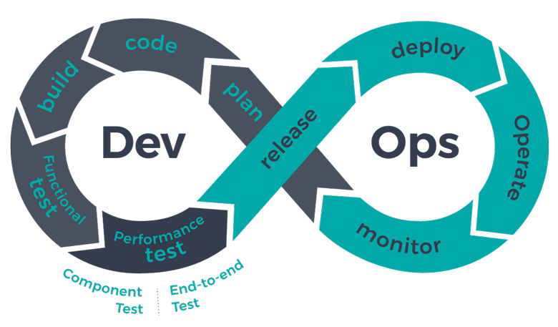](https://www.neotys.com/blog/wp-content/uploads/2018/05/DevOps-Cycle-no_words.png)

Because DevOps merges development and operations into one continuous flow that feeds on itself, it has given rise to the idea of the “full stack” developer. That is one who is familiar with all the stages of software development and deployment and can act on them.

The expertise of these folks might be expected in:

* Server, network, and hosting environment
* Relational and nonrelational databases
* Interacting with [APIs](https://www.neotys.com/resources/whitepaper/using-neoload-microservices-api-component-testing) and the external world
* User interface and the user experience
* Quality assurance
* Security
* Understanding customer and business needs

Rather than being an expert specialist, the [full stack developer](https://codeup.com/what-is-a-full-stack-developer/) is a competent generalist. By understanding how everything works from the top to the bottom of the software stack, they can anticipate problems.

This is the sort of team member that can understand how changes will propagate through an entire project, even though only one part of that change may be visible from within the current aspect. And this breadth of vision is what gives their contributions value to the project.

Not only that, a full stack developer will most likely end up using DevOps-style thinking and tools to gain what they want. Taking a whole stack viewpoint leads to using the same kinds of processes found in DevOps discipline since both approaches involve the entire process rather than just one part of it.

Agile and DevOps work together in separate ways. Agile focuses on the continual delivery of smaller parts of an overall project, while DevOps will look at how an entire project functions and can be tweaked to function even better. Their range of vision differs, much like a microscope and a telescope, but both will focus on the same project from their vantage points.

# Software Development

##### ***[ DevOps • SaaS • Code Takeover ]***

We believe in providing solutions. We offer a full range of custom software development services to meet all your technological needs — even the ones you haven’t thought of yet. Our team of experienced developers, programmers, and engineers provide a unique capacity for developing innovative products layered in complexity and designed exclusively for your business initiatives.

From concept to code, development to deployment. We have experience providing custom IT solutions that accelerate workflows, optimize operations and boost revenues. Whether you're looking to develop a new app for your business or improve your existing software environment, we offer the bespoke software development services you require.

Specializing in core product development areas ranging from enterprise infrastructure to low-level system applications, we deliver cutting-edge solutions that leverage our years of experience into robust end products with high availability. As your strategic partner, we supply the agility, responsiveness, and talent to provide cost-efficient solutions.

Application Development Custom Software Development

## Custom Application Development

We rely on our technological expertise and specialized industry experience to develop any type of web, mobile, desktop, and hybrid app per your business requirements.

Application Development Quality Assurance

## Quality Assurance and Software Testing

Comprehensive quality assurance is built into our custom software service model, but we can also provide on-demand QA and a suite of functional and usability software tests upon request.

Application Development Custom Software Development

## Application Maintenance

Our application maintenance and modernization services are designed to ensure the scalability, performance and sustainability of you entire software infrastructure as your business grows.

Application Development API Development

## API Development and Integration

We build and implement custom APIs for all breeds of applications, helping to add functionality to your software systems and facilitate communication between your apps and others.

Application Development Software Security

## IT Security Services

Thorough threat audits help us identify your software infrastructure's most pressing vulnerabilities, allowing us to integrate the encryptions, security services and access protocols you require.

Application Development Backup and Disaster Recovery

## Backup and Disaster Recovery

We implement incredibly robust data backup and recovery strategies for cloud-based, on-premises and hybrid servers, designed to ensure the integrity of your data and the continuity of your business.

Application Development Implementation and Deployment

## Implementation and Deployment

Our implementation specialists will work with your IT team to establish detailed software deployment objectives and timelines, covering configuration, testing, project governance, troubleshooting and more.

Application Development Infrastructure Support

## Infrastructure Support

Holistic IT Infrastructure support, including help desk management, custom messaging and collaboration, network management and system administration services.

Application Development Migrations and Upgrades

## Migrations and Upgrades

We perform cloud-based migrations, system upgrades and other vital software modernization services prioritizing system uptime and data integrity throughout an often daunting IT transition.

Application Development Software Integration

## Systems Integration

Integrating your applications is not just about making sure your various systems work together; it's about doing so in a way that's specific to your workflows, your departments and your business.

Application Development Product Lifecycle Management

## Product Lifecycle Management

Our agile, end-to-end Application Lifecycle Management (ALM) model covers everything from conceptualization, concurrent front- and back-end coding, deployment, QA and more.

Application Development SLA Support

## SLA Production Support

As software development service providers with 18 years of experience, you can trust us to put together a service level agreement that clearly lays out expectations for costs, timelines and system functionality.

# Cloud Adoption

TRANSFORMING BUSINESS THROUGH CLOUD

We help organizations to evaluate, strategize and transform businesses by leveraging cloud technology

Optimize cost with right virtualization strategy

## Cost Optimization

## Ensure high reliability & availability leveraging multi region solution

## Reliability and Availability Design

Designed for elasticity & scalability for growing business demand

## Elasticity and Scalability

## Business agility to innovate, develop and release features to customers with minimum risk

## Elasticity and Scalability

CLOUD TRANSFORMATION STRATEGY

Change the game by migrating to cloud - make it easy for employees, customers and partners to manage anything from anywhere at anytime

## Evaluate current Infrastructure & application

## Portfolio assessment Analysis, Strategy & Road Map

## Costing Analysis & ROI

## Migration assessment

## Evaluation and Analysis

* Cloud Migration Service
* Containerization (e.g. Kubernetes)
* Dev ops/ Continuous Delivery
* Cloud Re-engineering service /Multi cloud
* Cloud Native Development service
* Monitoring

## Cloud Shift

* Leverage New age solutions like AI/ML, IOT, Block chain
* Cost Utilization optimization (server less)
* Image/Video Analytics

## Cloud Tranform

CLOUD PARTNERS

Amazon Web Service | Google Cloud | Microsoft Azure | Alibaba Cloud

# IoT

We transform business needs into competitive differentiators by delivering innovative IoT powered solutions

## Connect and scale with efficiency

## Connectivity

## Analyze & act on real time data

## Analysis

## Improved decision making with augmented intelligence

## Improvement

## Improved decision making with augmented intelligence

## Integration

IoT Offerings

## Requirement elicitation and analysis

## Business process modelling with technology and process consulting

## Defining the problem statement along with recommendation on solution blueprint

## Product and service enhancements

## Consulting and Solution Development

## Open platform architecture with end-to-end connectivity

## Multi-tenant architecture to support IoT resources cost efficiently and securely

## Big data support with mashup builder and business intelligence

## Device vendor agnostic and device virtualization

## Secure, reliable, scalable and OTA firmware updates

## Building Intelligent Platforms

## End-device application development with multiple protocols and cross-platform support

## Native, mobile application development

## Application management with easy data import/export

## Re-engineering and optimization with iterative refinement and customer-driven design

## Application Development

## CRM and other web content

## ERP system integration

## SMS, email and payment gateway integration

## Map and billing engine integration

## Integrating multiple Internet of Things assets with different functionalities, departments and stages in product life cycle.

## End to End Integration

## Device lab testing (manual/automated)

## Device field testing

## Platform testing

## Mobile application testing

## Application automated testing

## Quality Assurance

IoT PARTNERS

ThingsBoard | Apache Spark | KAA | Strom | AWS IoT

# Mobility

WHAT WE OFFER

Enterprise Wide mobile-must approach that enhances customer experience across all touchpoints

* Personalized Content
* Boost Customer Engagement
* Business Intelligence at real time
* Improved efficiency using mobile analytics

MOBILITY OFFERINGS

## Personalization, Information/Content oriented apps

## Community, Engagement, Marketing, and Loyalty apps

## Transactions/Commerce Apps

## Integrated Smart Enterprise Apps

## Business Vertical Focused Apps

## Productivity and Workflow Apps

## Application Development

## Mobility Strategy Assessment

## Advisory for enterprises

## Architecture Assessment and Definition

## Mobile Technology Evaluation, Strategy, and Consulting

## Strategy and Design

## Payment Gateways (Online/Offline) ​

## IoT & Connected Devices

## CMS/Rich Media Servers

## Legacy Systems/ CRM

## Social Media

## End to End Integration

## Mobile Analytics – Interpretation & add business value

## Offline enablement Security

## Security and Efficiency

## Mobile Application lab testing (manual/automated)

## Application automated testing

## Quality Assurance

# Mobile Technology Expertise

Android | Swift | React Native | Adobe PhoneGap | Ionic | Flutter | Sencha | Appium | Appcelerator | Xamarin